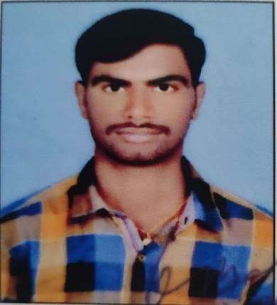

## Associate jr data scientist ________________________________________

Data Science/ Business Analytics/

Data Mining

Python, R.

## Machine Learning /AI :Python , R.

## Data Visualization: Qlik Sence .

programming languages: Python R

## Data mining Tools: SAS Enterprise Miner Excel Miner

## 

**Personal Details:**

DOB : 10/06/1996

PAN : CKRPA8405Q

Nationality : Indian

Languages : English Telugu

**AKULA KONDAIAH**

[**akulakondaiah9949@gmail.com**](mailto:akulakishore308@gmail.com)

**9949377833**

Having 3.1 years of strong experience in**, Machine Learning/AI, Applied**

**Business Analytics** solving various business problems with models for and strong business problem solving., Exploratory and Modeling data analyses to obtain insights from data and turn insight into action by creating predictive analytical business

solution. Solid expertise in **Descriptive-Predictive-Prescriptive** to solve

problems in highly competitive level

**EDUCATIONS**

MBA (Finance &Marketing) 2018

B.Sc. (Statistics ,Mathematics & Computer science) 2016

MPC (Mathematics , physics , Chemistry) 2013

SSC 2011.

**BUSINESS ANALYTICS & Data Mining**

* Descriptive Statistics, Descriptive Analytics using EDA techniques,

Inferential Analytics, Normalization techniques

* Predictive Analytics, Visualization, Summarization, Hypothesis, Data Quality

issues and outlier treatment.

* Business Intelligence using Tableau

**MACHINE lEARNING & AI algorithms**

* Supervised Learning: Linear Regression, Lasso , Ridge, Transformed regression Logistic, Decision Tree, CART, Naïve Bayes, SVM, ANN, Random forest, Ensemble, , Time series , ARIMA, AM
* Unsupervised Learning: Cluster, PCA.
* Deep Learning: ANN, CNN and RNN

**WORK EXPERIENCE**

Mahendrada Soft tech Solutions Pvt Ltd., Hyderabad,

Associate Jr Data Scientist 2018 to - till date

Playing Data Scientist role and involved in Data Science CoE (Center of Excellence) initiative from TechMahindra. Listed some of the key projects handled. As part of this job role, involved in all the phases of CRISP-DM/SEMMA methodology by using appropriate tools.

Project-1: Accident Analysis across Newyork and Newjersy:

Given 2 years of data of various accidents (includes car, bike and bicycle) with details, such as county, month and year of, left/right side, pressure and temperature, etc and expecting end result as an Andriod App for the end user with various dashboards. This solution is designed to bring awareness across various cities using various factors derived from the dashboard.

**Responsibilities:**

* Dashboard prototypes are using, plotly, matplot and seaborn in python.
* Build machine learning algorithms to identify the bad weather/outliers to alert the riders.
* Incorporated various statistical measures using stats, numpy and pandas. Performed various crosstabulations on data in multiple levels.
* Supervised the development/delivery of Andriod App with the appropriate dashboards to the customer.

Project-2: Anxiety and Depression Disorder Analysis:

Collected around 15,000 records from on various student’s information with their level of various levels of disorders such as Anxiety Disorder, Panic Disorder, Social Anxiety Disorder, Significant School Avoidance etc.

Responsibilities:

* Dashboard are prepared using streamlit and plotly in Python
* Performed Data Mining and applied descriptive statistics to collect facts for story telling
* Deployed the solution under streamlit and Heroku platforms
* Designed scalable data pipeline with ETL, data analysis and reporting intended to accommodate many more student records.